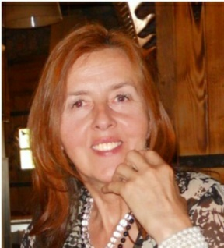
Curriculum vitae

- Family name: Lazović
- First names: Biljana
- Date of birth: 1962
- Nationality: Montenegrin
- Education:
Institution  [ Date from - Date to ] | Degree(s) or Diploma(s) obtained:
University of Novi Sad, Serbia (1995-1999) | PhD: Pomology, doctoral thesis in Oliviculture: ‘Pomological properties of introduced olive varieties (Olea europaea L.)’
University of Novi Sad, Serbia, (1987-1994) | M. Sc.: Pomology, master thesis in Oliviculture: 'Changes in the content and composition of proteins in olive during the active vegetation’
University of Novi Sad, Serbia (1980 – 1985) | B.Sc.: Fruit growing and viticulture field

- Language skills: Indicate competence on a scale of 1 to 5 (1 - excellent; 5 - basic)
Language | Reading | Speaking | Writing
English | 1 | 1 | 1
Italian | 2 | 3 | 3
Montenegrin/Serbo-Croatian/Bosnian (mother language)
- Other skills (e.g. Computer literacy, etc.): Windows, PPT, Excel
- Employment (institution): University of Montenegro (UCG), Biotechnical faculty (BTF), Centre for Subtropical cultures.
- Present position: Associate professor at University of Montenegro, Biotechnical Faculty.
- Years within the institution: 29 years
- Key qualifications: - Research in olive growing and olive oil technology, conservation and characterization of fruit genetic resources. - Teaching: Olive growing, Olive oil technology, Fruit breeding and Plant physiology.
12. Professional trainings: In the field of olive growing and olive oil quality (Moroko, 1990; Italy, 1995; Ciprus, 2001; Greece, 2005). Specialization in the field of biotechnology: three month at HRI in East Malling-England, 1998; two month in Israel (Rehovot, 2001), China (Guangdzou, 2003) and Greece (Thessaloniki, 2007). One month specialization in the field of 'Organic agriculture' at IAM Bari, Italy (2004); and more shorter programs: bioinformatics (Spain - Zaragoza, 2001), HACCP (France, Rennes, 2006), Management in gene bank (Alnarp, Sweden, 2006), Statistics in agriculture (Alnarp, Sweden, 2011), etc.
13. Research projects: International (SEEDNet project and two subprojects (2004-2011), FP7 REGPOT 2010 - 5 'AgriSciMont' project (2010-2013), SEE-ERANet project (2007-2008), RESGEN in olive (2012-2013), TEMPUS projects (3), national research projects of Ministry of science (2012-2015), and MASA/CANU (2015-2017), bilateral projects with Greece, Slovenia, BiH, Croatia, Italy, Serbia and Austria.
14. Publications: As the author and co-author published more than 80 scientific and professional papers in local and international Journals or presented at scientific congresses. As co-author, published five international and two national monographs.
15. Memberships: Vice dean for education at BTF (2007-2010); a member of the Committee for Agriculture of the Montenegrin Academy of Science and Arts (MASA/CANU) since 2014.

